Lab Task: Hello World & GDB Debugging (Assembly)

# Part 1: Hello World (Assembly)

1. Open a terminal and create a new file named 'hello.asm'.

2. Write the following NASM assembly code into 'hello.asm':

global _start  
  
 section .data  
 hello db "Hello World!", 10  
 length equ $ - hello  
  
 section .text  
 _start:  
 mov eax, 4  
 mov ebx, 1  
 mov ecx, hello  
 mov edx, length  
 int 0x80  
  
 xor ebx, ebx  
 mov eax, 1  
 int 0x80

3. Install NASM (if not installed):

sudo apt update

sudo apt install nasm -y

4. Compile the code:

nasm -f elf32 -g hello.asm -o hello.o

5. Link the object file:

ld -m elf_i386 hello.o -o hello

6. Run the executable:

./hello

Expected Output: Hello World!

Screenshot:  
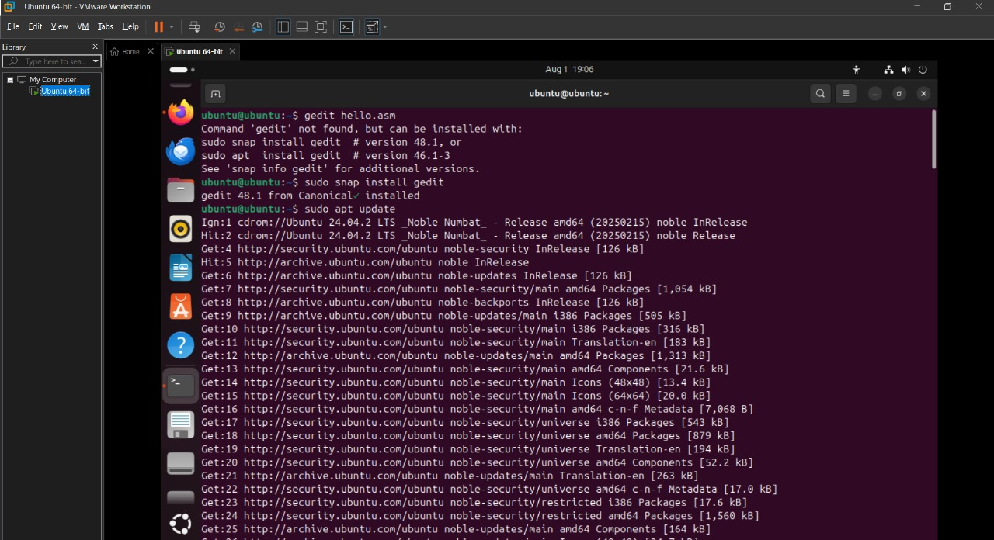

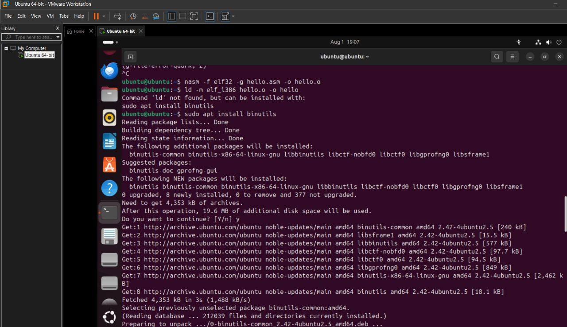  
  
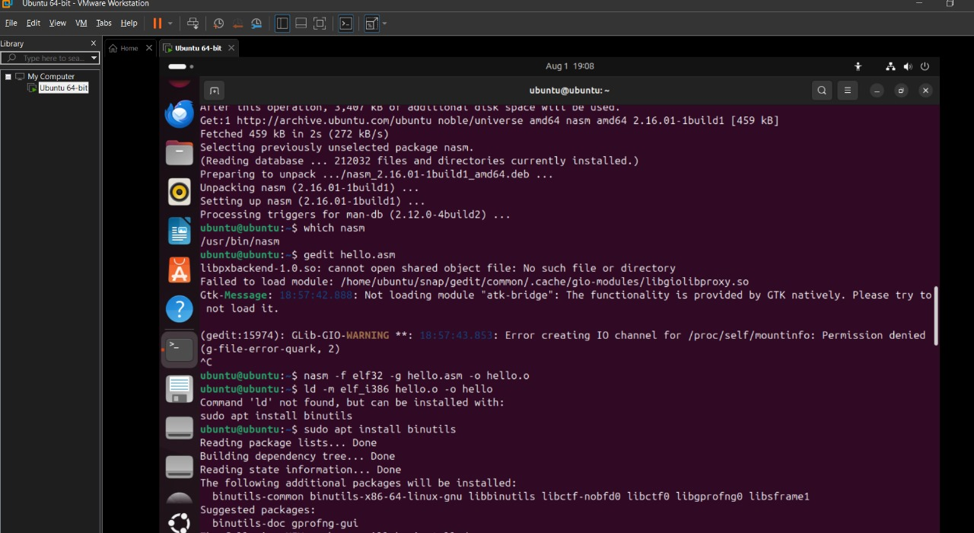  
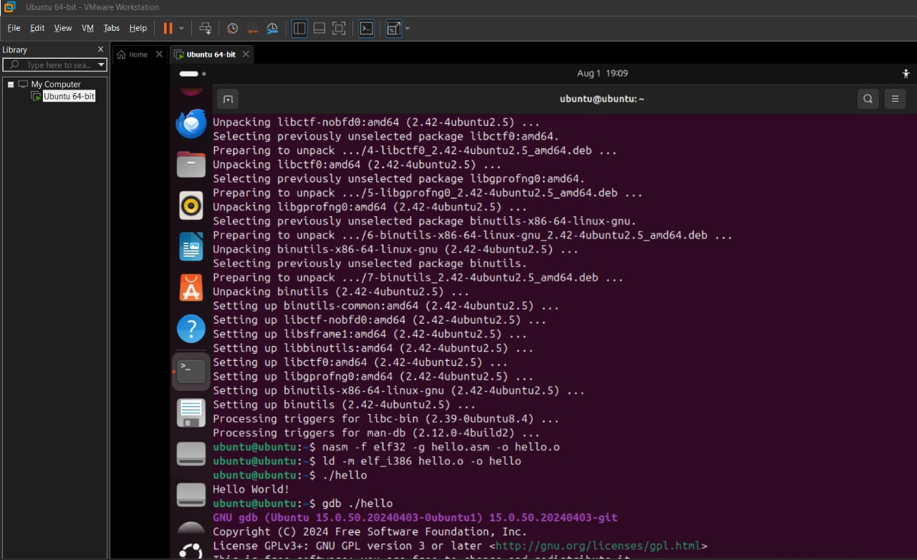

# Part 2: GDB Debugging of Hello World

1. Start GDB with the compiled program:

gdb ./hello

2. Set disassembly flavor to Intel syntax:

set disassembly-flavor intel

3. Set a breakpoint at the program start:

break _start

4. Run the program:

run

5. Disassemble the code and view registers:

disassemble _start

layout asm

layout reg

6. Step through instructions:

nexti

nexti (repeat as needed)

7. Quit GDB:

quit

Screenshot:  
